GUI Project: Validation Testing

Instructions: Create different sets of test data, record what you observe, then modify your code to correct any problems you find, and paste a screen shot of the program running correctly.

DATA SET #1: 1 Beef dog, 1 pork dog, 1 Turkey dog

Observations: program is computing sales Tax at 6%, to 7%

Fixes: change constant for SALES_TAX_RATE to 7%

Screen shots of program running correctly:

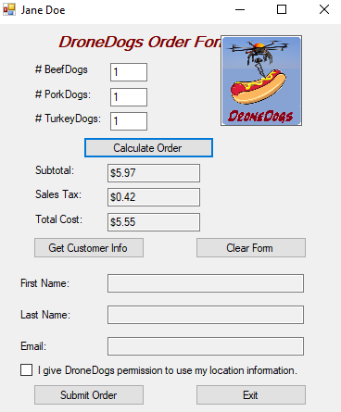

DATA SET #2: FristName, LastName, Email

Observations: program that compute how to select customer, Add customer

Fixes: change the customer name & Email or Add the new customer into customers form

Screen shots of program running correctly:

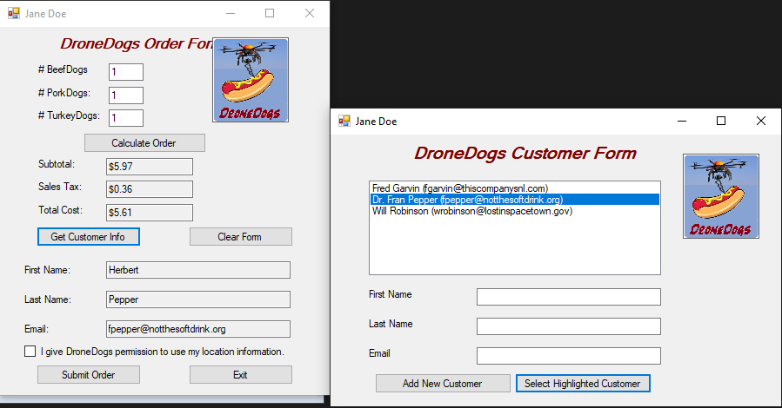

DATA SET #3: set data as checkbox

Observations: mark the checkbox before submit the order to avoid an error

Fixes: mark the checkbox means give permission to the system to submit the order

Screen shots of program running correctly:

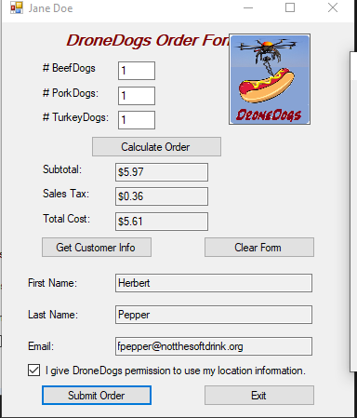

DATA SET #4: set the data submit the order and exit

Observations: runs the program and get the output

Fixes: error handling if program not give us the correct output

Screen shots of program running correctly:

